Open house 2 – Pine Valley Drive Pie Creek

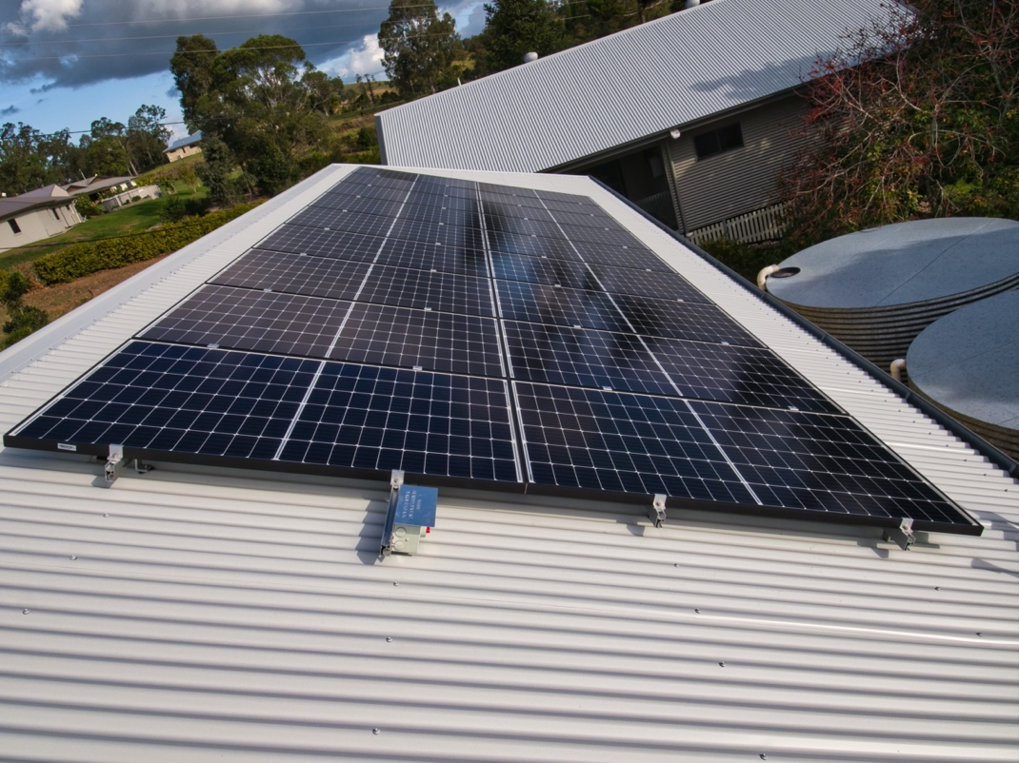

Our objectives:

When we built our home in 2005, we put into place a number of design features to make the home passively energy efficient while setting the roof pitch and orientation to allow the best placement of future solar panels. In 2007 our first solar panels were installed and over the intervening years improvements to lighting, domestic appliances and cooling were implemented as existing equipment passed its useful operational life.

The home now is effectively off grid (13.5 KWH battery) while remaining connected to the grid, (we feed in 30 KWH daily and purchase none) solar generation and energy stored is used to run two households when the sun isn’t shinning and provide energy to our electric car (20,000 plus kilometres).

Successes/Benefits:

Since 2007 we have not had a power bill and a we have received a steady return from our energy retailer. We produce more energy than we can consume and are looking forward to using more of our electrons for our transportation

Some missteps

As with all things its not difficult to be a hindsight evangelist and with respect to solar installation sizing that has been the case in recent times. Due to a hail event I had the need to replace our solar panels; no sooner were these installed (an 11 KWH system) then I asked myself ‘Why hadn’t I gone with a 15 KWH array given the minor price difference?’

Lessons learnt:

While it is useful to get the best feed in tariff possible, it’s very compelling to have ample self-generated power and to be able to enjoy self-consumption. Having a plan of what you would ultimately like to achieve is useful; if for no other reason, it would inform your early purchases to avoid redundancies by choosing the best type of inverter, the best for single or three phase power supply and so on.

