Open house 1 - Crown Road, Gympie

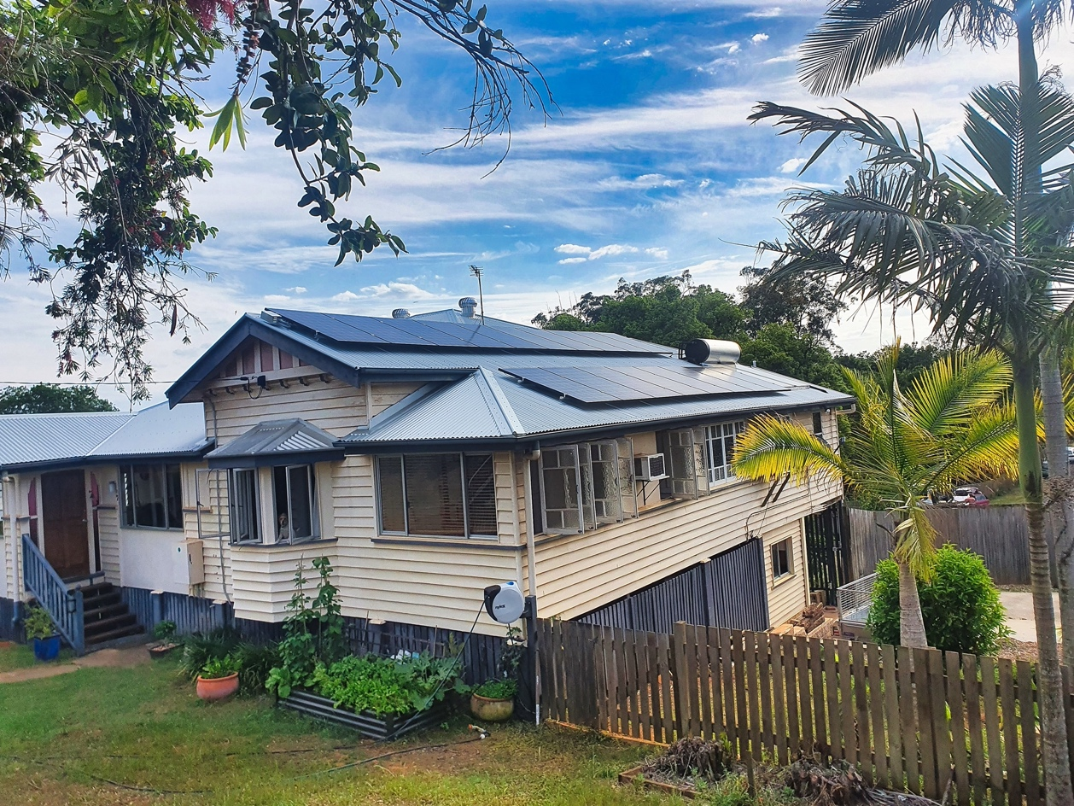

Our objectives:

To make energy efficiency gains, without compromising the aesthetic values of our 1940s Queenslander. The means we’ve identified fall into two categories:

- Reduce unnecessary energy consumption by removing/replacing old technology. Examples include replacing air-cons, removing wood heater, replacing halogens with LEDs.
- Make energy focused additions to the house, such as solar panels, solar hot water system, DC fans, an EV charging station, as well as a plan to install an induction cooktop.

Successes/Benefits:

Reduced electricity bill, increased ease of heating and cooling. Simplicity and reliability of solar hot water system, even with large bathtub - only run the booster twice in 12 months, for 4 hours at a turn, following a rainy week. During daylight hours, the whole household, including pool pump and EV run directly from the panels.

Some missteps

We should have replaced the ceiling insulation while the roof was being replaced. Additionally we perhaps could have anticipated the summer peak for tradies installing fans and air-cons, as we had to wait almost 2 months. We were surprised to have the plastic mouldings on the solar distribution board distort from UV exposure on the eastern side of the house.

Lessons learnt:

Ask your energy retailer for a better deal. Read broadly on options for all appliances. Consume your own energy throughout the day by using timers on appliances like dishwashers, washing machines, air-cons and when charging electric vehicles.

